**Problem 1**

1. This causes the expected count to stay below the observed for both ‘circle’ but increase above observed for ‘triangle’, until about ~1.11 which then reverses the roles of the expected count.
2. The red bar shows a decrease in the expected count and blue bar represents an increase in the expected count.
3. When solve is selected

1. When regularization l1 is selected.

1. This is due the regularization of the model which helps reduce the over and underfitting of the previous result.
2. Z ensures that the value we calculate does not exceed 1 meaning, allowing our result to be bounded between 0 and 1.

**Problem 2**

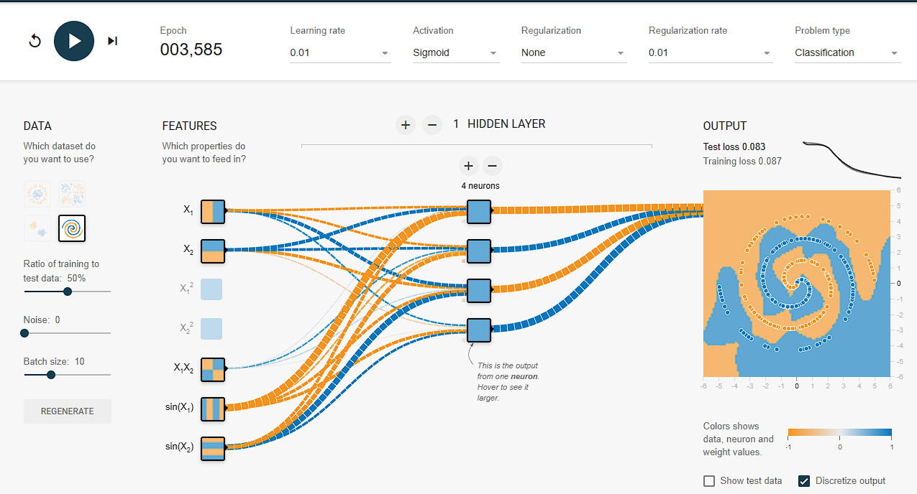

* Adding regularization should both lower the number of epochs and training/test loss

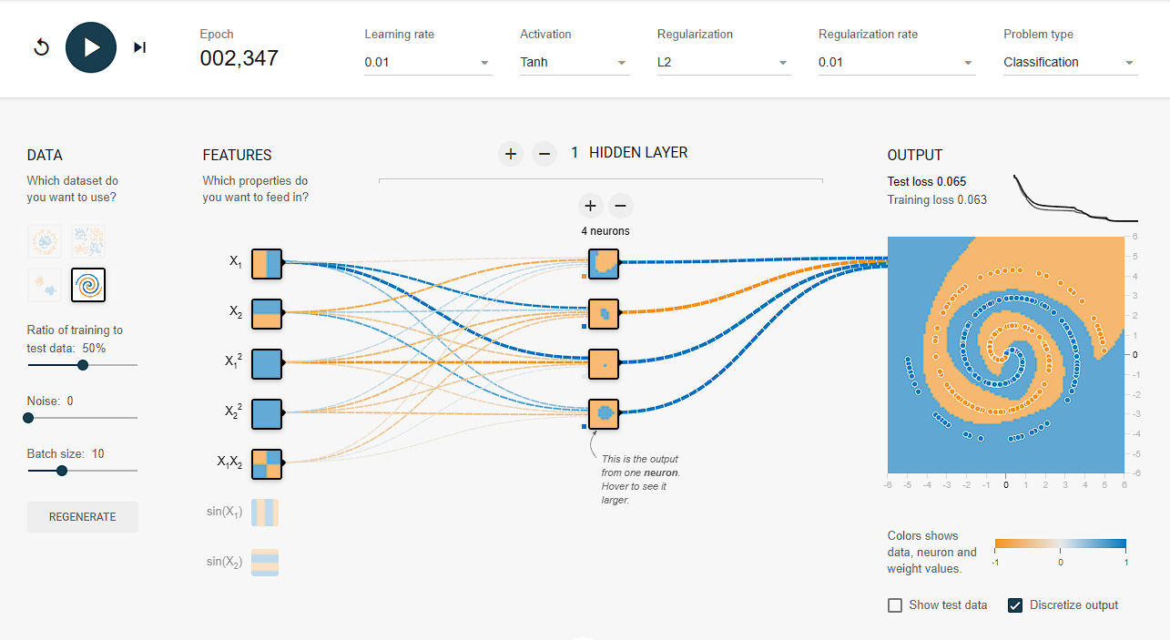

**Problem 3**

1. Kernel Size: 3x3

Stride length: 1

Maxpool window size: 2x2

1. This CNN only has two animals to compare against and so it seems fair to assume it would try to find a features that are similar. Thus, I believe this says that class ‘Espresso’ contains features that closely resemble those of the features identified in the ‘Coyote’ and ‘Rattlesnake’ classes.